
DAYANANDA SAGAR COLLEGE OF ENGINEERING
(An Autonomous Institute affiliated to Visvesvaraya Technological University (VTU), Belagavi,
Approved by AICTE and UGC, Accredited by NAAC with ‘A’ grade & ISO 9001 – 2015 Certified Institution)
Shavige Malleshwara Hills, Kumaraswamy Layout, Bengaluru-560 111, India

DEPARTMENT OF INFORMATION SCIENCE & ENGINEERING
(Accredited by NBA Tier 1: 2025-2028)

Full Stack Development Mini Project Report on
[22IS62]
Create a Chowka-Bara 5X5 game using JS React

Submitted in partial fulfillment for the award of the Degree of

Bachelor of Engineering
in
Information Science and Engineering

Submitted by

Bhoomika K Nayak | 1DS23IS031
Chandra Shekar GV | 1DS23IS035
Chetan S | 1DS23IS037
Dikshith M | 1DS23IS044

Under the Guidance of
Prof. Yogesh
Associate Professor
Department of Information Science and Engineering
DSCE, Bengaluru

VISVESVARAYA TECHNOLOGICAL UNIVERSITY
JNANASANGAMA, BELAGAVI-590018, KARNATAKA, INDIA
2025-26
DAYANANDA SAGAR COLLEGE OF ENGINEERING
(An Autonomous Institute affiliated to Visvesvaraya Technological University (VTU), Belagavi,
Approved by AICTE and UGC, Accredited by NAAC with ‘A’ grade & ISO 9001 – 2015 Certified Institution)
Shavige Malleshwara Hills, Kumaraswamy Layout, Bengaluru-560 111, India

DEPARTMENT OF INFORMATION SCIENCE & ENGINEERING
(Accredited by NBA Tier 1: 2025-2028)



CERTIFICATE

Certified that the project report entitled “Chowka-Bara 4X4 game using JS React” carried out by Bhoomika (1DS23IS031), Chandra Shekar GV(1DS23IS035), Chetan S (1DS23IS037) and Dikshith M (1DS23IS044), bonafide students of DAYANANDA SAGAR COLLEGE OF ENGINEERING, an autonomous institution affiliated to VTU, Belagavi in partial fulfillment for the award of Degree of Bachelor of Information Science and Engineering during the year 2025-2026. It is certified that all corrections/suggestions indicated for Internal Assessment have been incorporated in the report. The Full Stack Development Mini Project report has been approved as it satisfies the academic requirements with respect to the work prescribed for the said Degree.

Signature of the Guide  Prof. Yogesh  Associate Professor  Dept. of ISE, DSCE Bengaluru |  | Signature of the HoD  Dr. Annapurna P Patil  Dean Academics, Prof & Head  Dept. of ISE, DSCE, Bengaluru

DAYANANDA SAGAR COLLEGE OF ENGINEERING
(An Autonomous Institute affiliated to Visvesvaraya Technological University (VTU), Belagavi,
Approved by AICTE and UGC, Accredited by NAAC with ‘A’ grade & ISO 9001 – 2015 Certified Institution)
Shavige Malleshwara Hills, Kumaraswamy Layout, Bengaluru-560 111, India

DEPARTMENT OF INFORMATION SCIENCE & ENGINEERING
(Accredited by NBA Tier 1: 2025-2028)


DECLARATION

We, Bhoomika (1DS23IS031), Chandra Shekar GV(1DS23IS035), Chetan S (1DS23IS037) and Dikshith M (1DS23IS044),respectively, hereby declare that the project work entitled “ Chowka-Bara 5X5 game using JS React” has been independently done by us under the guidance of ‘Prof Yogesh’, Associate Professor, ISE department and submitted in partial fulfillment of the requirement for the award of the degree of Bachelor of Information Science and Engineering at Dayananda Sagar College of Engineering, an autonomous institution affiliated to VTU, Belagavi during the academic year 2025-2026.
We further declare that we have not submitted this report either in part or in full to any other university for the award of any degree.

Bhoomika K Nayak | 1DS23IS031
Chandra Shekar GV | 1DS23IS035
Chetan S | 1DS23IS037
Dikshith M | 1DS23IS044

PLACE:
DATE:
ABSTRACT
The Chowka-Bara 4×4 Game is a web-based application developed using modern frontend technologies such as React and JavaScript. Chowka-Bara is a traditional Indian board game that has been played for generations, particularly in rural regions. The main objective of this project is to recreate the classic game in a digital format, allowing users to access and play it easily through web browsers without requiring any physical setup.
This project focuses on designing an interactive and user-friendly interface that closely simulates the original gameplay experience. The 4×4 board is implemented using React components, where each cell represents a position on the board. Players interact with the game through simple controls such as rolling a dice and moving tokens. The core game logic, including player movement, turn management, and win conditions, is implemented using JavaScript to ensure accuracy and smooth functionality.
One of the major advantages of this system is its accessibility. Unlike the traditional version, which requires a physical board and multiple players, this digital implementation allows users to play anytime and from anywhere. React’s efficient state management enables real-time updates, ensuring a smooth and responsive gaming experience.
Furthermore, the project highlights how traditional cultural games can be preserved and modernized using current technologies. It also provides valuable learning experience in frontend development, component-based architecture, and event-driven programming.
Overall, the system serves both as an engaging entertainment platform and as an educational tool for understanding modern web development concepts.
Keywords:
Chowka-Bara, React JS, JavaScript, Web Application, Game Development, Frontend Development, Component-Based Architecture, State Management, User Interface, Traditional Games, Digital Transformation.

Table of Contents

ABSTRACT iii
ACKNOWLEDGMENT iv
LIST OF TABLES vii
LIST OF FIGURES viii
LIST OF ABBREVIATIONS AND SYMBOLS ix
- INTRODUCTION………………………………………………………………………..1
1.1 Overview
1.2 Problem Statement
1.3 Objectives
- REQUIREMENT ANALYSIS & DESIGN………………………………………. 4
  - Analysis
  - Hardware Requirements
  - Software Requirements
  - System Architecture Diagram
- IMPLEMENTATION/ METHODOLOGY / PROPOSED APPROACH…..8
4.1 Algorithms or techniques to be used (e.g Explain JS, Express, react, css, db)
4.2 Description of data collection process (if applicable)
4.3 Core Module Implementation
4.4 Work Flow Diagram
4.5 Algorithm/Code
4.6 Project running steps and {git hub location}
5. TESTING………………………………………………………………………...…………13
5.1 Testing Strategy
5.2 Test Cases and Results

6. RESULTS and DISCUSSIONS………………………………………………………..16
6.1 Experimental Results
6.2 Explain challenges faced during project
6.3 Discussion of Findings

7. CONCLUSION and FUTURE WORK………………………………………………18
7.1 Summary of Project
7.2 Contributions
7.3 Limitations
7.4 Future Enhancements

1.INTRODUCTION
The rapid advancement of web technologies has enabled the transformation of traditional systems into digital platforms. One such area is the digitization of traditional board games, which not only preserves cultural heritage but also enhances accessibility and user engagement. This project focuses on developing a web-based version of the traditional Indian game Chowka-Bara using modern technologies like React and JavaScript.
Chowka-Bara is a popular indoor game played using a board and dice, requiring strategy and planning. However, with the growing influence of digital entertainment, such traditional games are gradually losing their popularity. This project aims to revive the game by implementing it in a digital format that can be easily accessed through web browsers.
The application is designed to provide an interactive and user-friendly interface, allowing players to experience the gameplay without the need for physical components. The system focuses on implementing core game logic, responsive design, and smooth user interaction using a component-based architecture.
1.1 OVERVIEW
The Chowka-Bara 4×4 Game is a frontend web application developed using React, JavaScript, HTML, and CSS. The purpose of this project is to create a digital version of the traditional game that can be played online with ease.
The system consists of a 4×4 grid representing the game board, where players move their tokens based on dice rolls. The application uses React components to structure the UI, making it modular and easy to manage. Each part of the game, such as the board, players, and dice, is implemented as a separate component.
JavaScript is used to handle the game logic, including random dice generation, player movement, turn management, and win conditions. The use of React ensures efficient state management, allowing real-time updates of the game interface without reloading the page.
The application is designed to be responsive, ensuring compatibility across different devices such as desktops, tablets, and smartphones. This makes the game accessible anytime and anywhere.
Overall, the project demonstrates how traditional games can be modernized using web technologies while maintaining their original essence.
1.2 PROBLEM STATEMENT
Traditional games like Chowka-Bara are gradually losing their popularity due to the rapid growth of digital entertainment such as mobile games and online platforms. Most younger generations are unfamiliar with these cultural games because they lack easy access and exposure. Physical gameplay requires a board, tokens, and multiple players, which makes it inconvenient in today’s fast-paced digital world.
There is a need to digitize such traditional games so that they can be preserved and made accessible to a wider audience. Without digital transformation, these games may eventually disappear from mainstream usage. Furthermore, there are very few simple and lightweight web-based implementations of such games that focus on ease of use and accessibility.
Another challenge is to design a system that accurately replicates the rules and logic of the original game while maintaining a smooth and interactive user experience. The system should be simple enough for beginners while still maintaining the authenticity of the gameplay.
Therefore, this project aims to develop a Chowka-Bara 4×4 game using React and JavaScript that provides a digital platform for users to play the game easily. The solution should be user-friendly, responsive, and capable of running on any modern web browser without requiring complex setup.
1.3 OBJECTIVES
The main objectives of this project are:
- To design and develop a digital version of the Chowka-Bara game using React
- To implement core game functionalities such as dice rolling, player movement, and win detection using JavaScript
- To create an interactive and visually appealing user interface using HTML and CSS
- To ensure the application is responsive and works across different devices
- To provide a simple and user-friendly platform for gameplay
- To enhance understanding of frontend technologies and component-based development
- To preserve and promote traditional games through digital transformation

2.REQUIREMENT ANALYSIS & DESIGN
Requirement analysis is an important phase in software development where the needs and functionalities of the system are identified and defined. In this project, the requirements for developing the Chowka-Bara 4×4 game are analyzed to ensure proper design and smooth implementation.
The design phase focuses on structuring the system architecture, identifying components, and defining how different parts of the application interact with each other. Since this is a frontend-based web application, the primary focus is on user interaction, game logic, and interface design.
The system is designed to be simple, efficient, and user-friendly, ensuring that even users with minimal technical knowledge can easily play the game.
2.1 SYSTEM ANALYSIS
System analysis involves understanding the functional and non-functional requirements of the application.
Functional Requirements:
- The system should display a 4×4 game board
- Users should be able to start and play the game easily
- The system should generate random dice values
- Players should be able to move tokens based on dice rolls
- The system should manage turns between players
- The system should detect winning conditions and display results
Non-Functional Requirements:
- The system should be responsive and work on different devices
- The application should have a simple and intuitive user interface
- The system should perform efficiently without delays
- The game should run smoothly in modern web browsers
- The code should be modular and maintainable
The analysis ensures that all required features are clearly defined before implementation.
2.2 HARDWARE REQUIREMENTS
The hardware requirements for this project are minimal since it is a lightweight web-based application.
- System: Laptop or Desktop Computer
- Processor: Intel i3 or above
- RAM: Minimum 4 GB (8 GB recommended for smooth performance)
- Storage: At least 500 MB free space
- Input Devices: Keyboard and Mouse
- Display: Standard monitor or mobile screen
Since the application runs in a browser, no high-end hardware is required.
2.3 SOFTWARE REQUIREMENTS
The software requirements include tools and technologies used for development and execution.
- Operating System: Windows / macOS / Linux
- Frontend Technology: React JS
- Programming Language: JavaScript
- Markup & Styling: HTML, CSS
- Development Tool: Visual Studio Code
- Runtime Environment: Node.js
- Package Manager: npm (Node Package Manager)
- Web Browser: Google Chrome / Firefox / Edge
These tools help in building, running, and testing the application efficiently.
2.4 SYSTEM ARCHITECTURE DIAGRAM
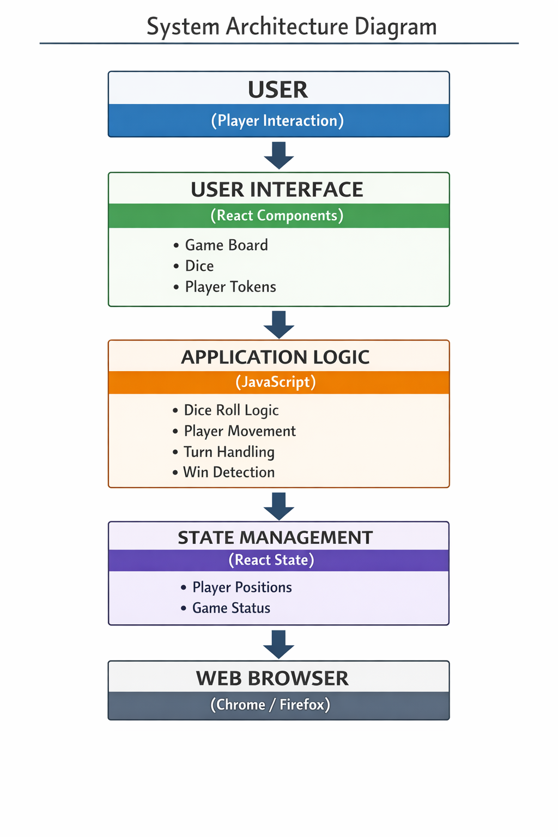

The system architecture represents the overall structure of the application and how different components interact.
Since this is a frontend-based application, it follows a component-based architecture using React.
The system architecture of the Chowka-Bara game follows a component-based structure using React. The user interacts with the application through the user interface, which consists of React components like the game board, dice, and player tokens.
The application logic layer, implemented using JavaScript, processes user actions such as dice rolling and player movement. React state management is used to store and update game data dynamically. The entire application runs within a web browser, which renders the interface and executes the logic.

3.IMPLEMENTATION/ METHODOLOGY / PROPOSED APPROACH
The implementation of the Chowka-Bara 4×4 game is carried out using a frontend-based approach with modern web technologies such as React and JavaScript. The system is designed following a component-based architecture, where the entire application is divided into smaller, reusable modules. Each module is responsible for a specific functionality, such as rendering the game board, handling player movements, managing dice rolls, and updating the game state. This modular design improves code readability, reusability, and maintainability.
The proposed approach focuses on building a simple, interactive, and user-friendly system that replicates the traditional gameplay in a digital format. React is used to create dynamic and responsive user interfaces, allowing real-time updates without reloading the page. JavaScript is used to implement the core game logic, including random dice generation, player movement rules, turn management, and win condition checking. CSS is used to design the layout of the game board and enhance the visual appearance of the application.
State management plays a crucial role in the implementation of this system. React’s state and hooks are used to store and update important game data such as player positions, current turn, dice values, and game status. Whenever a user performs an action, such as clicking the dice button, the state is updated accordingly, and the UI reflects these changes instantly. This ensures smooth gameplay and better user experience.
The application follows a structured step-by-step workflow. Initially, the game is initialized with default values, including player positions and game settings. When the user interacts with the system, such as rolling the dice, the input is processed by the application logic. Based on the generated dice value, the player’s position is updated according to the game rules. The system then checks for valid moves and determines whether the player has reached the winning condition.
If no player has won, the turn is passed to the next player, and the process continues. All updates are reflected in the user interface in real time using React’s rendering mechanism. The game continues until a player satisfies the winning condition, after which the result is displayed.
Overall, this implementation ensures efficient performance, smooth interaction, and an engaging user experience while preserving the core essence of the traditional Chowka-Bara game in a modern digital format.
3.1 ALGORITHMS / TECHNOLOGIES USED
The project uses the following technologies:
- React JS: Used to build the user interface with reusable components like Board, Dice, and Player
- JavaScript: Implements core logic such as dice rolling, movement, and win conditions
- CSS: Used for styling and layout of the game board
- HTML: Provides structure for rendering components
- (Optional Express/DB): Not required as this is a frontend-only game.
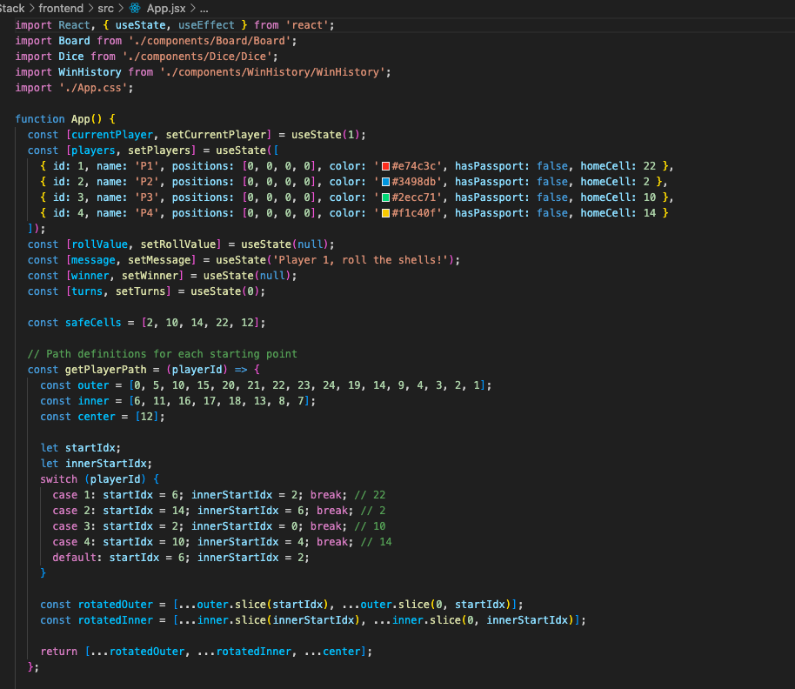
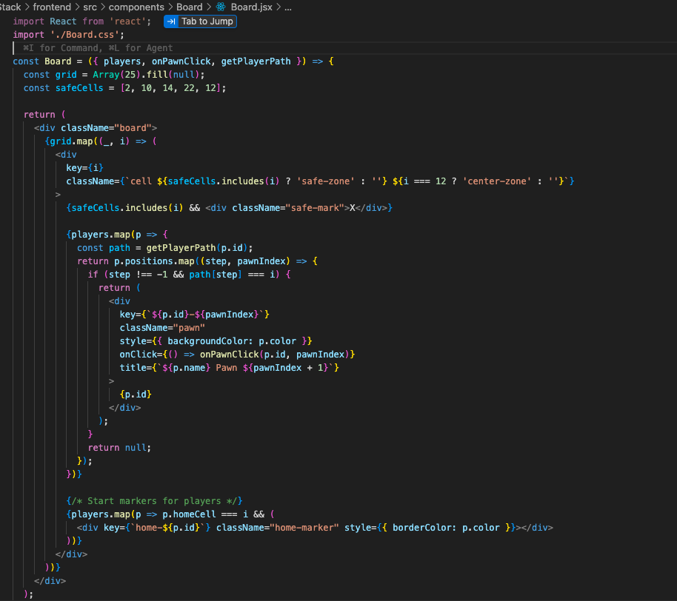
Technique Used:
- Component-Based Design
- Event Handling (onClick for dice roll)
- State Management using React Hooks
3.2 DATA COLLECTION PROCESS
Since this is a game-based application, no external data collection is required.
All data used in the system is:
- Generated internally (dice values using random function)
- Stored temporarily using React state
- Reset after game completion
Thus, the system does not depend on any database or external API.
3.3 CORE MODULE IMPLEMENTATION
The system is divided into the following modules:
1. Game Board Module
- Displays 4×4 grid
- Handles layout using CSS Grid
2. Dice Module
- Generates random number (1–6)
- Triggered by user click
3. Player Module
- Tracks player positions
- Handles movement logic
4. Game Logic Module
- Controls turns
- Validates moves
- Checks winning condition
3.4 WORKFLOW DIAGRAM
The workflow of the system begins with the user starting the game. The player rolls the dice, and based on the result, the token moves forward. The system checks if the move is valid and updates the game state. The process continues until a player reaches the winning condition

5. TESTING
Testing is an important phase in software development that ensures the system works correctly and meets the specified requirements. In this project, testing is performed to verify that the Chowka-Bara 4×4 game functions properly without errors and provides a smooth user experience.
The testing process involves checking different components of the application such as dice functionality, player movement, turn handling, and win conditions. Since the system is developed using React and JavaScript, both functional and user interface testing are carried out.
The main objective of testing is to identify bugs, ensure correctness of game logic, and improve the reliability of the system. Different test cases are executed to validate the behavior of the application under various conditions.
5.1 TESTING STRATEGY
The testing strategy used for this project includes multiple approaches to ensure overall system quality.
1. Unit Testing
Each component such as the dice module, player movement, and board rendering is tested individually to ensure it works correctly.
2. Functional Testing
The system is tested to verify that all functionalities work as expected:
- Dice generates random values
- Players move correctly
- Turns switch properly
- Winning condition is detected
3. User Interface Testing
The UI is tested to ensure:
- Proper layout of the 4×4 grid
- Buttons and controls work correctly
- The design is responsive across devices
4. TEST CASES AND RESULTS
Test Case ID | Description | Expected Result | Actual Result | Status
TC01 | Start Game | Game initializes correctly | Same as expected | Pass
TC02 | Roll Dice | Random number (1–6) generated | Correct output | Pass
TC03 | Player Movement | Player moves based on dice value | Correct movement | Pass
TC04 | Turn Switching | Next player gets turn | Working properly | Pass
TC05 | Boundary Check | Player stays within board limits | Validated | Pass
TC06 | Win Condition | Winner is detected correctly | Correct result | Pass
TC07 | UI Responsiveness | Layout adjusts on all devices | Responsive | Pass

All the test cases were successfully executed, and the system performed as expected. The application is stable, user-friendly, and free from major errors.

6. RESULTS AND DISCUSSIONS
The Results and Discussion section presents the outcome of the developed Chowka-Bara 4×4 game and analyzes its performance, usability, and effectiveness. After successful implementation and testing, the system was evaluated based on functionality, user interaction, and overall performance.
The application was able to execute all core features such as dice rolling, player movement, turn management, and win detection accurately. The use of React ensured smooth rendering and real-time updates, resulting in a responsive and interactive user experience. The system performed efficiently without noticeable delays, and all components worked together seamlessly.
This section also highlights the challenges faced during development and provides insights into the findings obtained from the project.
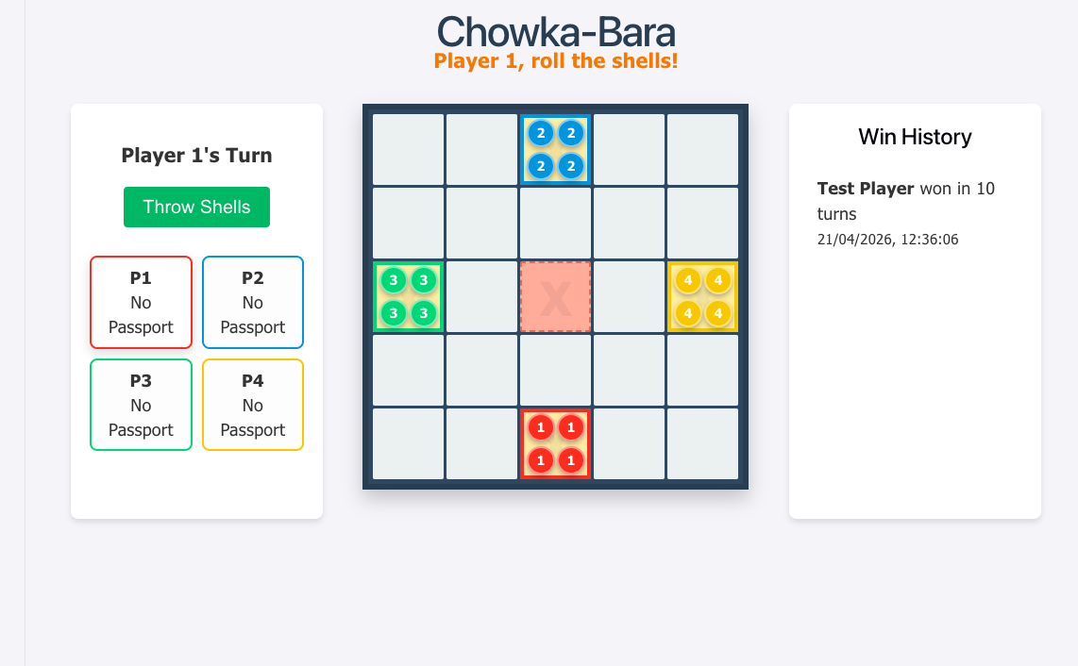
6.1 EXPERIMENTAL RESULTS
The experimental results indicate that the developed system meets all the intended objectives. The application was tested under different scenarios to verify its functionality and performance.
- The dice module successfully generated random values between 1 and 6
- Player movement was accurate and followed the defined game rules
- Turn management worked correctly between multiple players
- The system correctly identified and displayed the winner
- The user interface responded dynamically to user inputs without page reload
- The application worked smoothly across different devices and browsers
The results confirm that the system is stable, reliable, and user-friendly. The game provides an engaging experience while maintaining the logic of the traditional Chowka-Bara game.
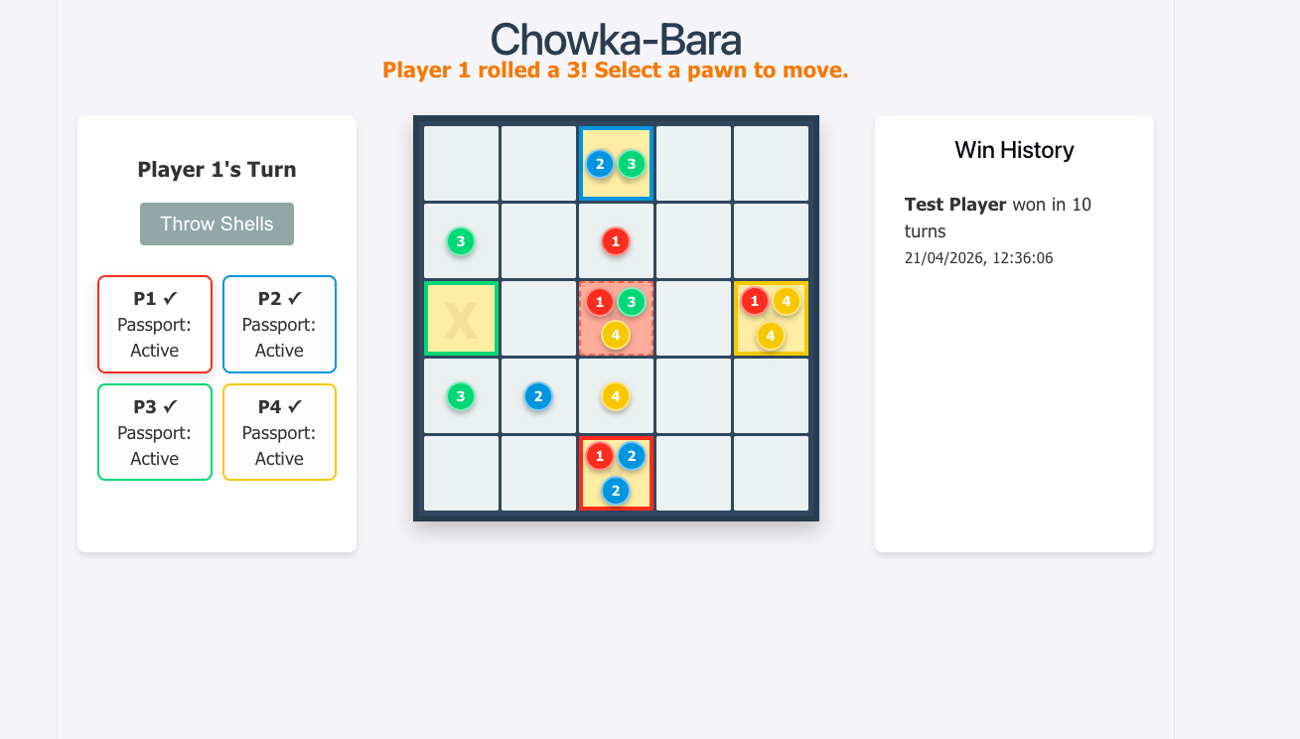
6.2 CHALLENGES FACED DURING PROJECT
During the development of the project, several challenges were encountered.
One of the major challenges was implementing the correct game logic, especially player movement based on dice values. Ensuring that all moves followed the rules of the game required careful planning and testing. Handling edge cases such as boundary limits and invalid moves was also difficult.
Another challenge was managing state in React. Since the application depends heavily on dynamic updates, maintaining synchronization between different components was essential. Improper state handling could lead to incorrect UI updates or unexpected behavior.
Designing a responsive and visually appealing user interface was also challenging. Ensuring proper alignment of the 4×4 grid and adapting the layout for different screen sizes required multiple adjustments in CSS.
Debugging errors and ensuring smooth interaction between components was time-consuming. However, these challenges were overcome through continuous testing and refinement.
6.3 DISCUSSION OF FINDINGS
The findings from this project show that React is highly effective for developing interactive web-based applications. The component-based architecture made it easier to organize the code and manage different parts of the system.
The use of JavaScript for implementing game logic proved to be efficient and flexible. It allowed easy handling of events, conditions, and dynamic updates. React’s state management system played a crucial role in ensuring that all changes were reflected instantly in the user interface.
The project also demonstrates that traditional games can be successfully digitized using modern web technologies. This not only helps in preserving cultural heritage but also makes such games more accessible to a wider audience.
Overall, the system achieved its intended goals and provided a smooth and interactive gaming experience. The project also helped in improving technical skills in frontend development, problem-solving, and system design.

7. CONCLUSION AND FUTURE WORK
The Chowka-Bara 4×4 game project successfully demonstrates how a traditional board game can be transformed into a modern web-based application using technologies like React and JavaScript. The system was designed and implemented with a focus on simplicity, interactivity, and efficient performance.
Through this project, all the core functionalities of the game such as dice rolling, player movement, turn handling, and win detection were successfully implemented. The application provides a smooth and responsive user experience, making it easy for users to play the game without requiring any physical setup.
This project not only helps in preserving a traditional game but also serves as a practical example of frontend development using component-based architecture.
7.1 SUMMARY OF PROJECT
The project involves the design and development of a digital version of the Chowka-Bara game using React and JavaScript. The system allows users to interact with a 4×4 game board, roll dice, and move players based on the game rules.
The application follows a structured workflow, starting from user interaction to processing game logic and updating the interface dynamically. React is used to manage components and state, while JavaScript handles the core logic of the game.
The system was tested thoroughly and was found to be reliable, efficient, and user-friendly. Overall, the project successfully meets its objectives and provides an engaging gaming experience.
7.2 CONTRIBUTIONS
The key contributions of this project are as follows:
- Development of a digital version of a traditional Indian game
- Implementation of game logic using JavaScript
- Use of React for building a dynamic and responsive user interface
- Creation of a modular and maintainable system using component-based design
- Enhancement of user experience through interactive gameplay
- Contribution towards preserving cultural heritage through technology
7.3 LIMITATIONS
Despite successful implementation, the project has certain limitations:
- The game currently supports only basic gameplay and limited features
- No multiplayer or online connectivity is available
- No database is used for storing game history or scores
- The application lacks advanced graphics and animations
- AI-based opponent functionality is not implemented
These limitations can be addressed in future improvements.
7.4 FUTURE ENHANCEMENTS
The system can be further improved by adding the following features:
- Implementation of multiplayer mode (online/offline)
- Addition of AI opponent for single-player mode
- Integration of database to store scores and game history
- Enhancement of UI with animations and sound effects
- Development of a mobile application version
- Adding user authentication and profiles
These enhancements will make the system more interactive, scalable, and user-friendly.

